**Embargoed until 6am, Thursday 15th December 2022**

**PRESS RELEASE:**

**Ground-breaking study by local people reveals shocking levels of river water pollution along the river Kent in Cumbria**

**The Clean River Kent Campaign (CRKC) has released a study presenting the results of their water quality monitoring at six locations between February and September 2022 from Staveley to Sedgwick on the river Kent in Cumbria - a designated Site of Special Scientific Interest (SSSI).**

**The water samples were collected to a rigorous protocol by trained citizen scientists and analysed in an accredited laboratory for *E. coli* and *Enterococcus spp*.**

**The results show that at all six locations the quality of the river water was assessed as Poor (the worst category) due to high levels of both faecal bacterial pathogens. Results were particularly bad at the location immediately downstream of Staveley Wastewater Treatment Works (sewage works).**

**This is the first time that such information has been made available for this river. This breakthrough study signals risks to human health and serious concerns for ecology and wildlife.**

**The quality of river water should be safeguarded by the water companies and their regulators. In 2022 the dire state of our rivers hit the national headlines time and time again. CRKC calls on both United Utilities, the local water and sewage company, and their regulators (the Environment Agency and Ofwat) to respond to our request for action. We call on local organisations and policy makers to act together as a matter of urgency, to hold those responsible to account, and to work with us to clean up the river.**

* 100 volunteer citizen scientists have collected ground-breaking data about levels of faecal bacteria pollution, for the first time ever on the river Kent.
* The breakthrough results show that every one of the six locations failed to meet the minimum standard for Inland Bathing Water as defined by DEFRA.
* CRKC is calling on water companies and regulators to safeguard the river Kent; and for regulators and local organisations to work with us to hold polluters to account.
* CRKC has applied for bathing water status for a stretch of the river Kent to ensure that there is regular water quality monitoring by the Environment Agency going forward.

A local coalition of over 100 volunteer citizen scientists, concerned about harmful pollution, collected water from six locations along the river Kent at Staveley, Beckmickle Ing, Burneside, Kendal (Sandy Bottoms – Dockray Hall Bridge), Hawes Bridge and Sedgwick between February and September 2022 *(See* ***Map 1*** *below showing location of testing locations).*

All six locations are used regularly for swimming, water sports, angling and in summer families spend time on the banks of the river picnicking and paddling.

The river water was tested for *E. coli* and *Enterococcus spp* (two types of faecal bacteria) in an accredited laboratory.

This is a unique dataset. No organisation (neither polluters nor regulators) has assessed faecal bacterial pollution in the river Kent before. This is the first time ever that any systematic information has been made available about the levels of faecal contamination in the river water.

The breakthrough results show that every one of the six locations failed to meet the minimum standard for Inland Bathing Water as defined by DEFRA[1]. The water quality at all six locations was classified as Poor, the worst category. (*See graphs below* *from full report:* <https://bit.ly/3FRwub3> *)*

The results at Beckmickle Ing, just downstream of Staveley Wastewater Treatment Works (WwTW), were particularly worrying. Despite numerous requests, United Utilities has been unable to provide a full dataset on the performance of this WwTW in terms of the frequency and duration of spills, although another local study by Staveley with Ings Parish Council, has revealed the extent to which untreated sewage is discharged into the river.

Tim Farron, MP for Westmorland and Lonsdale, says,

*“The data collected by CRKC and the Parish Council doesn’t surprise me at all. For years now, due to underinvestment in infrastructure, residents in Staveley have suffered from raw sewage regularly overflowing onto their streets as well as into the river.”*

*“An FOI request by local people in 2021 disclosed that there had been an ’emergency’ discharge of untreated effluent 1,000 times during 2019 to 2021 directly into the River Kent from the Staveley sewage treatment works – an average of once a day. “*

*“These new results should be used to hold the responsible polluters to account.”*

Dr Gill Notman, Senior Lecturer in Marine and Freshwater Conservation, Institute of Science & Environment, University of Cumbria commented,

*“The hard work of this team of dedicated local volunteers has shone a spotlight on the threats facing not just the river Kent but many of our rivers in Cumbria.”*

*“Only 14% of UK rivers are rated “good” by the EU, and in the Lake District National Park only 4% of SSSI rivers are in favourable condition.” [2]*

*“We need to take urgent action to stop the on-going decline of our precious resources by unacceptable levels of pollution from various sources including wastewater treatment works, agriculture and septic tanks.”*

Carole Wood (CRKC member and resident of Kendal) explains that:

*“The river Kent is a unique river that has almost every designation possible – it is a national Site of Special Scientific Interest (SSSI) and an international Special Area of Conservation (SAC) due to the presence of certain species including the white-clawed crayfish, bullhead and freshwater pearl mussel.”*

*“It runs through the Lake District National Park with UNESCO world class heritage status and is cherished by local people and used for a wide range of recreational activities including world-class kayaking.”*

*“However, despite all these designations it is still polluted. “*

*“It is vitally important that our local river is cleaned up to protect this internationally significant environment for the future, for both the health of our communities and also to protect wildlife and biodiversity.”*

The results should also be set in the context of a growing awareness of problems with wastewater and sewage in Staveley, Bowston and Burneside. Staveley with Ings Parish Council has expressed these concerns for many years and has now resorted to undertaking its own monitoring of the Staveley sewage treatment works.

Since 25 February 2022, 138 observations have been made at the riverside location of the Staveley WwTW “dump pipe”. Over half (54%) of these observations recorded that the “dump pipe” was discharging (78 out of 138 times), most frequently during wet periods in the autumn.

Arthur Capstick, Staveley Parish Councillor, Sewage Group Lead says,

“*The Parish Council continues to be in discussions with United Utilities about the adequacy of the sewage treatment works but has not yet received any guarantee of improvement. “*

*“From regular observations made this year by local volunteers on behalf of the Parish Council, it is now clear that untreated or partly treated sewage is repeatedly discharged from the site directly into the river Kent.”*

*“This combined and growing body of evidence from the community must now further the case for urgent investment and improvement.”*

In October 2022 the Clean River Kent Campaign applied to DEFRA for Bathing Water Status at a site in Staveley above the WwTW. So far only two rivers in England have achieved this – the Wharfe at Ilkley and the Thames near Oxford compared to 573 rivers with bathing status in France.

Although the River Kent is well used for water-based leisure activities, there is no current requirement on either United Utilities or the Environment Agency (EA) to test for faecal bacteria unless DEFRA designates the stretch of river as having bathing water status. If the application is successful, this will require regular bacterial monitoring of the river by the EA going forward, and provide information for the local community about the levels of faecal bacterial pollution in the water.

In the New Year CRKC will start fundraising to carry out further monitoring of the river Kent to develop this unique body of evidence of harmful river pollution.

**Notes for Editors:**

1. The **Clean River Kent Campaign** (CRKC) was established in Autumn 2021. We are a voluntary coalition of communities living along the river Kent, Cumbria. Our aim is to keep the river Kent clean for water-based recreation and to protect wildlife and ecology. Our initial objective is to significantly reduce the amount of effluent discharged into the river by United Utilities wastewater treatment works and/or by storm overflows.
2. Contact Clean River Kent Campaign: istoddart@gmail.com / 07952 786621 for more information, interviews, quotes, or images. *(Permissions received for use of photos below).*
3. More general information on the overall CRKC campaign, including a couple of videos produced by local filmmakers/volunteers: <http://www.sustainablestaveley.org.uk/clean-up-the-kent/>
4. The full CRKC report, showing the water quality results is available here: <https://bit.ly/3FRwub3>
5. A dissertation, by a University of Cumbria degree student about the water quality in and around Staveley is available here: <https://bit.ly/3P4Uhao>
6. A copy of CRKC’s application for Bathing Water Designation on a stretch of the river in Staveley is available here: <https://bit.ly/3is2pp0>
7. Clean River Kent facebook page**: @cleanriverkent**

*Untreated sewage flowing into the river Kent from Staveley WWT*

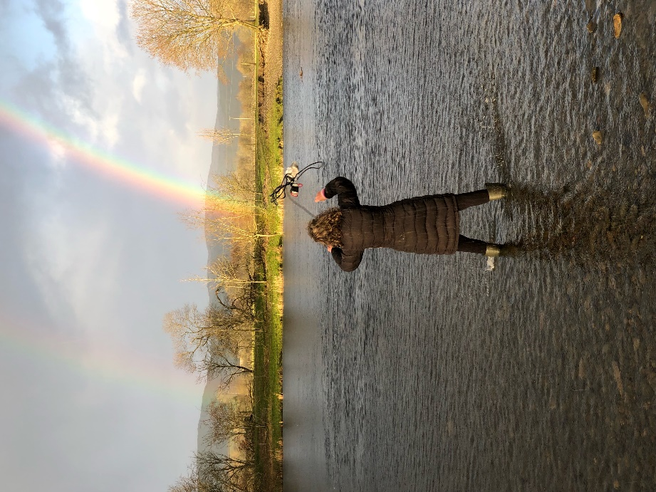

*CRKC volunteer undertaking water sampling on the river Kent*

*Children enjoying swimming in the river Kent*

**MAP 1 – Locations of water quality testing sites – river Kent, Cumbria**

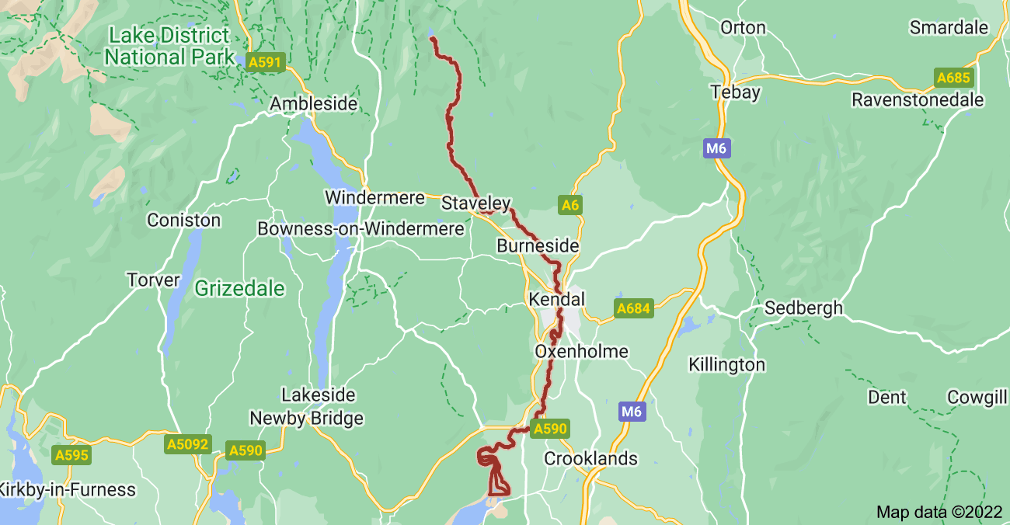

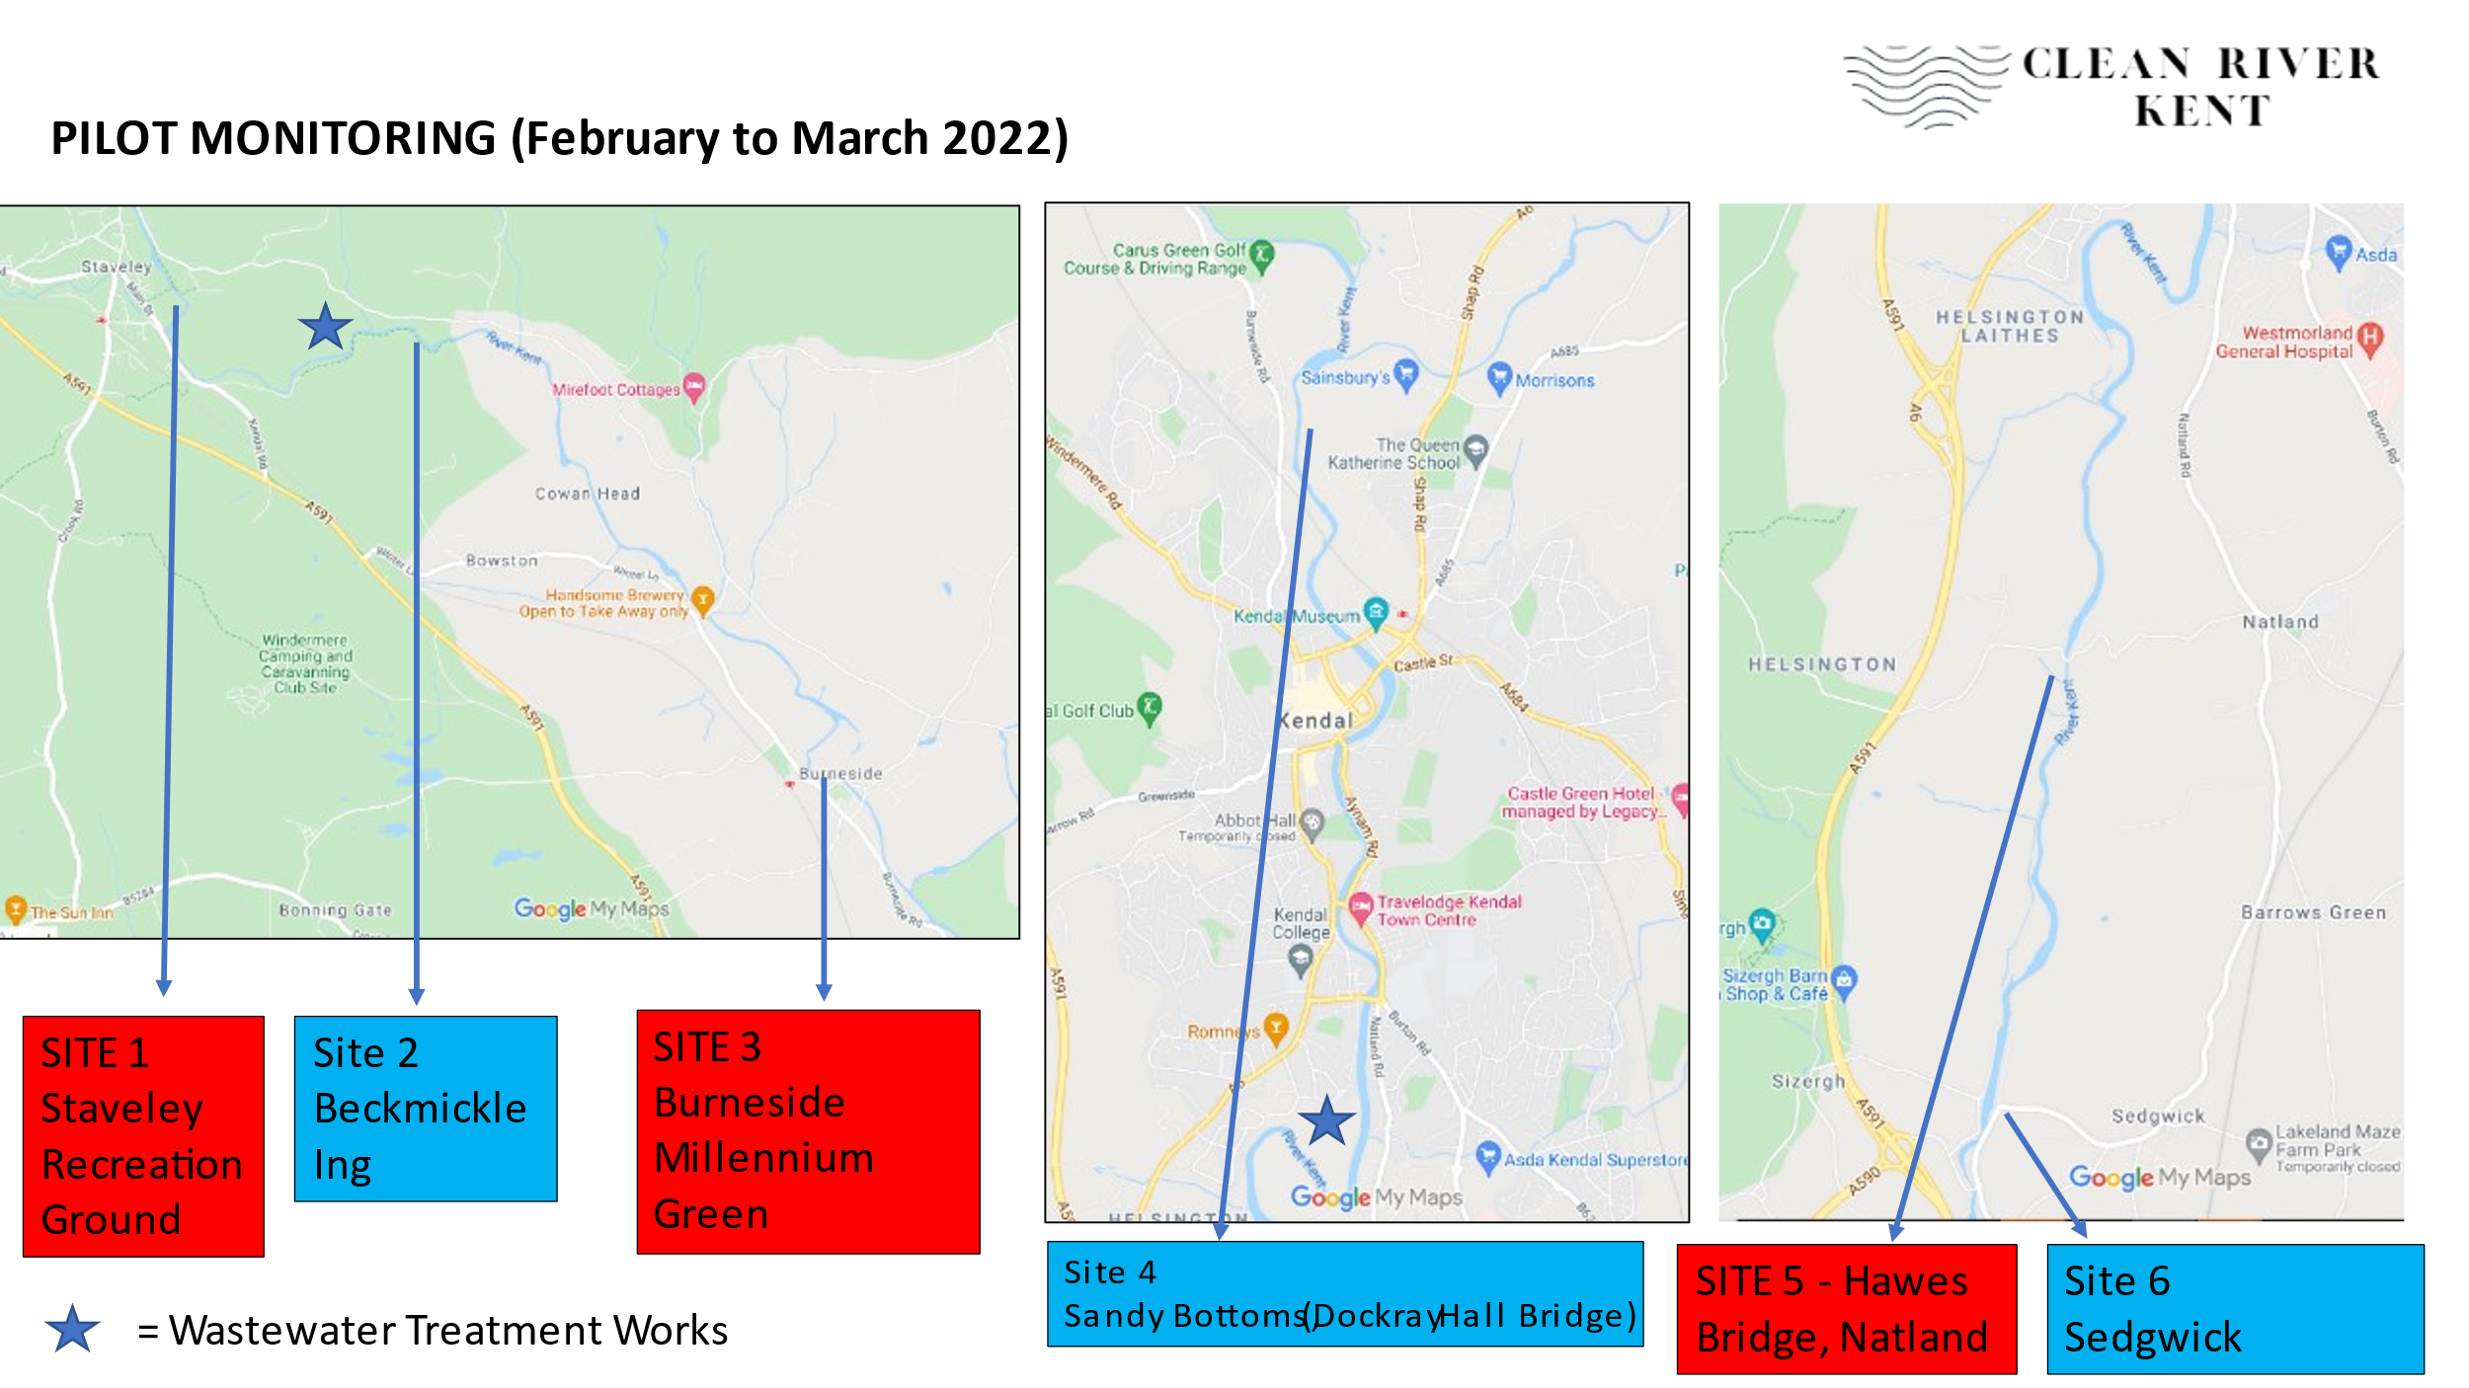

Graphs showing that the bacterial counts for both *E. coli* and *Enterococcus spp* exceeded the 90th percentile at every one of the six locations along the river Kent. In all cases the water quality should be regarded as Poor.

**The 90th percentile for *E. coli* at each monitoring location**

***Figure 3 - Graph showing the 90th percentile for E. coli at each monitoring location***

*(>900 colony forming units cfu/100ml = poor water quality status)*

**The 90th percentile for *Enterococcus spp* at each monitoring location**

***Figure 4 – Graph showing the 90th percentile for Enterococcus spp at each monitoring location***

*(>330 colony forming units cfu/100ml = poor water quality status)*

**END**

1. 90th percentile worse than 900 cfu/100ml for *Escherichia coli*

   90th percentile worse than 330 cfu/100ml *for Enterococcus*
2. Lake District National Park Authority’s State of the National Park report, 2018 - <https://bit.ly/3VzKcom>