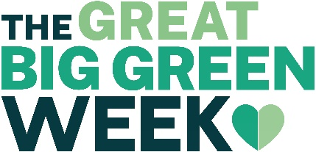

PRESS RELEASE:
Staveley celebrates Great Big Green Week 2021 (18 – 26th September) with films, talks, walks, competitions, events and much more. ALL FREE, ALL WELCOME!
Staveley invites everyone - residents, visitors and businesses alike - to celebrate Great Big Green Week 2021, and take part in lots of fun, ‘green’ events, organised by SENS (Sustainability and Energy Network in Staveley). All the events are free and open to everyone – just turn up! Refreshments provided by SENS and the Women’s Institute.
Events taking place between 18 and 26th September in Staveley, to promote local action on climate change include: 2 litter picks, an information stand with books, information, pledges, campaigns and advice; 2 ‘green’ film shows (including short films by local filmmakers), a guided walk around the woodlands/allotments; a talk / Q&A session about making your home more energy efficient, and a river dipping session run by South Cumbria Rivers Trust.
And throughout the week Cumbria Wildlife Trust has organised a Staveley-wide Bioblitz plus a collection of tree, flower and vegetable seeds for a new Staveley Seedbank, whilst The Big Onion is holding a plant swap – bring a plant, take a plant!
Please come along, and spread the word about the events to your friends, family and work colleagues.
Isobel Stoddart, Chair of SENS says, “Great Big Green Week is a wonderful opportunity for our community to celebrate our achievements to combat climate change in interesting, practical ways. SENS hope that as many people as possible will attend the events which should be fun and informative at the same time with activities for both children and adults alike. With COP26 just around the corner, now is the time for everyone to show how much they care for the future of our community – both the people and also the special environment we live in. Each of us can make a difference in our own way – so get involved!”

A full event programme, with downloadable posters for each event is available at: http://www.sustainablestaveley.org.uk/greenweek/

Notes for Editors:
- Contact SENS: senstaveley@gmail.com / 07952 786621 for more information, interviews, quotes or images. More information on Staveley’s Great Big Green Week 2021 including a full timetable and posters see: http://www.sustainablestaveley.org.uk/greenweek/
- SENS was formed in November 2007 to promote sustainability action in the village, by looking at ways to reduce home energy use, explore the potential for hydro-electric schemes, promote cycling and walking, develop renewable technologies, protect biodiversity and raise awareness of and take action on climate change. www.sustainablestaveley.org.uk/
- SENS produce a monthly newsletter - to subscribe email: senstaveley@gmail.com
- Great Big Green Week 2021 is a nationwide celebration of action on climate change, taking place across the UK from the 18 - 26 September 2021.
- For more information about COP26 (31st Oct to 12 Nov, 2021): https://ukcop26.org/
- Staveley’s Great Big Green Week is funded by the National Lottery Community Fund and is part of the Zero Carbon Cumbria Partnership’s ambitious emission reduction programme to make Cumbria carbon neutral by 2037.

